Journey from Volunteering to Research
(Times New Roman, 15pt, Bold)

Gildong Hong, Gildong Kim²
(Times New Roman, 11pt, Bold)

Hankook International School, Seoul, Korea
(Times New Roman, 11pt, Italic)

Abstract(12pt, Bold)

Para sport can advance rehabilitation, health, confidence, and social participation, (Times New Roman, 10pt)

Keywords(10pt, Bold): para sport, classification, eligible impairment, sport class, participation barriers, rehabilitation(Times New Roman, 10pt)

Introduction(12pt, Bold)

Background and Rationale(11pt, Bold)
For people with disabilities, sport contributes to rehabilitation, health promotion, confidence, and social integration.(Times New Roman, 10pt)

Methods(12pt, Bold)

To minimize potential bias arising from the researcher’s multiple roles as a volunteer, observer, and resource developer, clinical evaluations and impairment assessments were conducted independently by licensed rehabilitation physicians(Times New Roman, 10pt).

Results(12pt, Bold)

The project charted a student’s growth from event volunteer to bilingual information translator to co-researcher creating case pathways. Mentorship ensured ethical and clinical rigor(Times New Roman, 10pt).

Table 1. Descriptive Statistics and Reliability(Times New Roman, 11pt).
Variable(Times New Roman 9pt, Bold) | Mean | SD | Cronbach’s α
Positive Affect(Times New Roman 9pt) | 0.00 | 0.00 | .00
Negative Affect | 0.00 | 0.00 | .00
Mental Privacy Awareness | 0.00 | 0.00 | .00
Data-Sharing Intention | 0.00 | 0.00 | .00

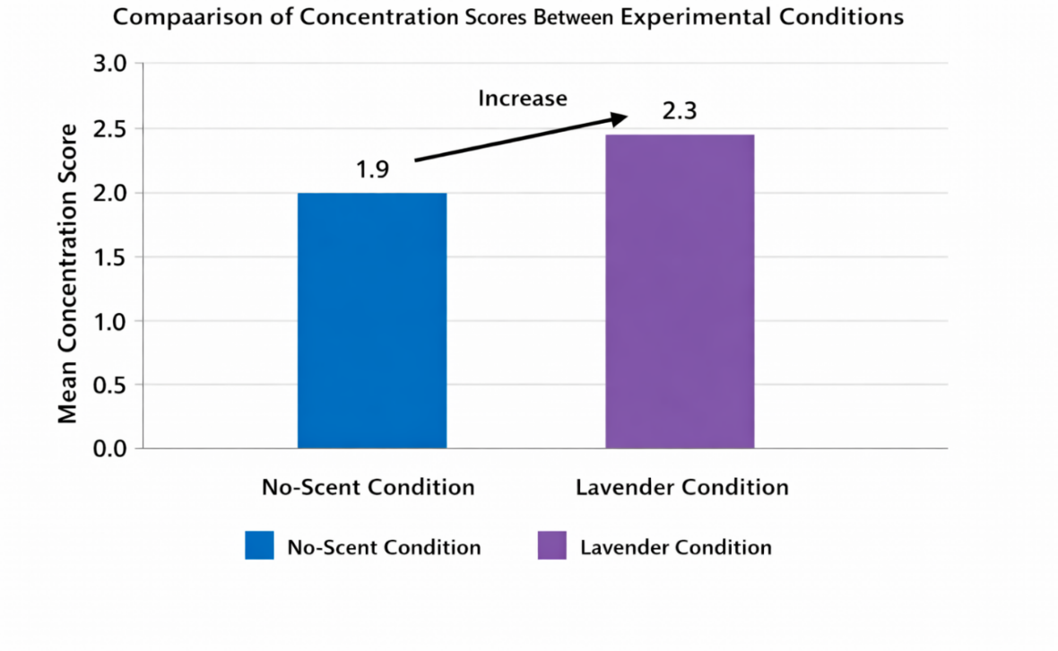
Figure 1: Comparison of Concentration Scores Between Experimental Conditions
(Times New Roman, 11pt)

Discussion(12pt, Bold)
Through direct experience and a national report review, this study identified key issues in Korea’s para sport classification system(Times New Roman, 10pt).

Conclusion(12pt, Bold)

The most notable challenges included a shortage of trained classifiers, large infrastructure gaps across sports, centralization in Seoul, and a lack of accessible information(Han et al., 2023)(Times New Roman, 10pt).

References(12pt, Bold, References are prepared in APA style(7th edition))

International Paralympic Committee. (2025). Paralympic classification(Times New Roman, 10pt). https://www.paralympic.org/classification
Tweedy, S. M., & Vanlandewijck, Y. C. (2011). International Paralympic Committee position stand: Background and scientific principles of classification in Paralympic sport. British Journal of Sports Medicine, 45(4), 259–269.

Hankook International School, Seoul, Korea, E-mail: ²Hankook International School, Seoul, Korea, E-mail:

